GUIDE FOR ONLINE PARTICIPATION IN EXTRAORDINARY GENERAL MEETING SALMON EVOLUTION ASA, 2 MAY 2022
Salmon Evolution ASA will hold an extraordinary general meeting on Monday 2 May 2022, at 10:00 am(CEST) as a digital meeting, where you get the opportunity to participate online with your PC, phone or tablet. Below is a description of how to participate online.

We also point out that you also can vote in advance or give a proxy before the meeting. See the notice for further details on advance voting and how to authorize a proxy. If you vote in advance or give a proxy, you can still log on to the general meeting to follow and ask questions, but you will not have the opportunity to vote on the items. If required a proxy can be withdrawn by requesting this once logged on.

By participating online, shareholders will receive a live webcast from the general meeting, the opportunity to ask written questions, and vote on each of the items. Secure identification of shareholders is done by using the unique reference number and PIN code assigned to each shareholder by the Norwegian Central Securities Depository (Euronext VPS) in relation to this General Meeting.
No registration is required for shareholders who want to participate online, but shareholders must be logged in before the general meeting starts.
Shareholder who does not find their reference number and PIN code for access or have other technical questions is welcome to call DNB Registrars Department on phone + 47 23 26 80 20 (between 08:00-15:30 (CEST)), or send an e-mail to genf@dnb.no
HOW TO ACCESS THE ONLINE GENERAL MEETING
To be able to participate online, you must go to the following website: https://web.lumiagm.com
either on your smartphone, tablet or PC. All major known browsers, such as Chrome, Safari, Edge, Firefox etc. are supported.
enter Meeting ID: 197-623-958 and click Join.
You must then identify yourself with.
a) Ref. number from VPS for the general meeting
b) PIN code from VPS for general meeting
You will have the opportunity to log in one hour before the general meeting starts.
Once you have logged in, you will be taken to the information page for the general meeting. Here you will find information from the company, and how this works technically. Note that you must have internet access throughout the meeting.

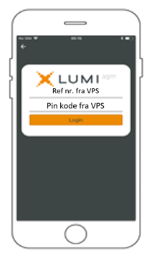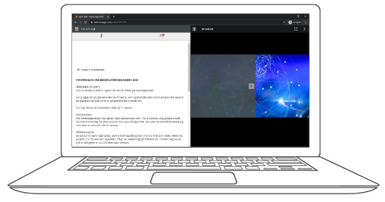

HOW TO RECEIVE YOUR REFERENCE NUMBER AND PIN CODE

All shareholders registered in the VPS are assigned their own unique reference and PIN code for use in the General Meeting, available to each shareholder through VPS Investor Services. Access VPS Investor Services, select Corporate Actions, General Meeting. Click on the ISIN and you can see your reference number (Ref.nr.) and PIN code.
All VPS directly registered shareholders have access to investor services either via https://www.euronextvps.no or internet bank. Contact your VPS account operator if you do not have access.
Shareholders who have not selected electronic corporate messages in Investor Services will also receive their reference number and PIN code by post together with the summons from the company (on registration form).
Custodian registered shareholders: Shares held through Custodians (nominee) accounts must be transferred to a segregated VPS account registered in the name of the shareholder to have voting rights on the General Meeting. Once shares are transferred to the segregated VPS account, a reference number and PIN code are assigned to this account. Please contact your custodian for further information.
HOW TO VOTE
When items are available for voting, you can vote on all items as quickly as you wish. Items are closed for voting as the general meeting considers them. Items will be pushed to your screen. Click on the vote icon if you click away from the poll.  To vote, press your choice on each of the issues. FOR, AGAINST or ABSTAIN. Once you have cast your vote, you will see that your choice is marked. You also get a choice where you can vote jointly on all items. If you use this option, you can still override the choice on items one by one if desired.  To change your voice, click on another option. You can also choose to cancel. You can change or cancel your vote until the chair of the meeting concludes the voting on the individual items. Your last choice will be valid.  NB: Logged in shareholders who have voted in advance or given a power of attorney will not have the opportunity to vote but can follow and write messages if desired. | 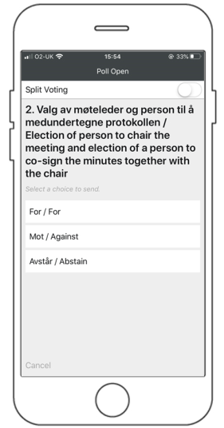

QUESTIONS TO THE CHAIRPERSON
Questions or messages relating to the items on the agenda can be submitted by the shareholder or appointed proxy at any time during the meeting as long as chair of the meeting holds this open.
If you would like to ask a question relating to the items on the agenda, select the messaging icon.
Enter your question in the message box that says "Ask a Question". When you have finished writing your question, click on the submit button.
Questions submitted online will be moderated before going to the chair. This is to avoid repetition of questions as well as removal of inappropriate language.
All shareholders who submit questions will be identified with their full names, but not holding of shares.

